Lab #4: Invoice Generator

*Carson Kramer*

*March 9th, 2023*

ALGORITHM

* Step 1: House creation
  + Prompt and error check client name, maximum number of rooms, and mileage
  + Enter into 3 argument constructor for new house object
* Step 2: Add – List – Quit menu Do While loop
  + Note: Use toupper() function to allow for upper or lowercase characters
* Step 3: Generate invoice
  + Sections:
    - Labor Charges
    - Product Charges
    - Travel Charges

House Class (room class composition):

* Global:
  + Hourly rate (18.50)
  + Milage cost (0.67)
  + Paint cost (70.35)
* Private:
  + Client name (string)
  + Maximum number of rooms (int)
  + Distance needed to be traveled (float)
  + Rooms needed painted (vector)
* Public:
  + Default & Multiargument constructor (default values in multi-argument)
  + Destructor
  + Get & Set (name, max num of rooms, distance)
  + addRoom (public vector addition)
    - first check to make sure that the maximum number of rooms has not already been exceeded
  + listRooms (void print)
  + numberOfRooms (public vector access)
  + Save to file (void)
  + Total amount of paint for the full house (float)
  + Number of coats of paint in a single job (int)
  + Number of paint cans needed for a single room in the vector at a given position (int)

Room Class:

* Global:
  + paintPerGallon (const int)
* Private:
  + Length (float)
  + Width (float)
  + Height (float)
  + Number of coats (int)
  + Volume (float)
  + Surface Area (float)
  + calculateGallonsNeeded (float)
* Public:
  + Default & Multi-argument constructor (default values in multi-argument)
  + Destructor
  + Get & Set (length, width, height, coats)
  + Save to file (void, input ofstream)

SCREEN-SHOTS OF RUNNING PROGRAM

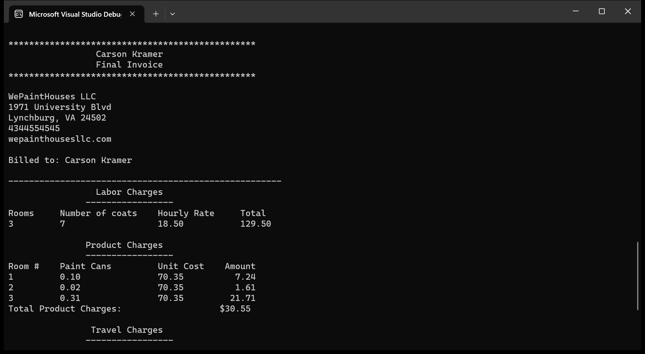

INTEGRITY STATEMENTS

* I have not shared the source code in my program with anyone other than the pre-approved human sources.
  + *Please include a note here if you have used one or more of the pre-approved human sources or received special permission from me.*
* I have not used source code obtained from another student, or any other unauthorized source, either modified or unmodified.
* If any source code or documentation used in my program was obtained from another source, such as the course textbook or course notes, that has been clearly noted with a proper citation in the comments of my program.
  + It would also be helpful to include a note here of which sources you used
* I have not knowingly designed this program in such a way as to defeat or interfere with the normal operation of any machine it is graded on or to produce apparently correct results when in fact it does not.

Note: These statements serve as your personal promise that the above is true. If I find that you have not been true to ALL of the four statements above, you will get a zero for the assignment and receive an academic violation report (which goes on your academic record). Both are minor compared to the loss of your integrity.